**ISCG7425 – Enterprise Java Programming**

**Lab Session 2**

Struts Framework + JDBC

Setup the example Struts project provided on moodle – altering the database connection details to suit your database credentials. Alter the database query code so that a user is able to search the database based on author and genre.

Note: you will need to use a proper J2EE container for this lab session so when you setup your server make sure you download a copy of Tomcat 7 to d:\tomcat\.

1. Add a fuzzy search <s:checkbox name="fuzzy" label="Fuzzy Search"/> checkbox tag to the JSP form with appropriate backing code to toggle whether the Action POJO does a strict search or a *like* based SQL wildcard search.

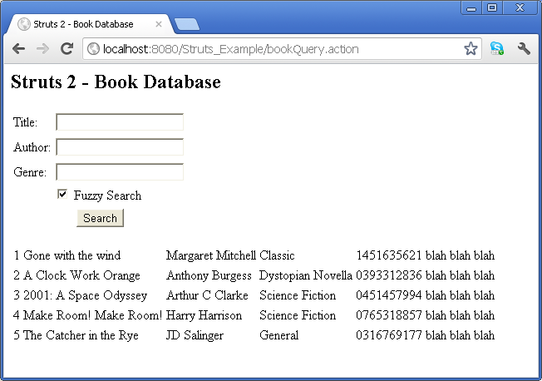

1. Use dependency injection to create a public void validate() method by extending the support class ActionSupport. The validation method should ensure that a user has entered at least one criteria (genre, title, author). Use the addFieldError(“key”,”text”) and addActionError (“message”) methods to raise a validation exception as required.
2. Experiment with the placement of the <s:actionerror/> and <s:fielderror fieldName="title" /> tags to specify the location of the error message in the linked JSP page. Note. That the Struts form element automatically associates a field error with an s:textfield form element.

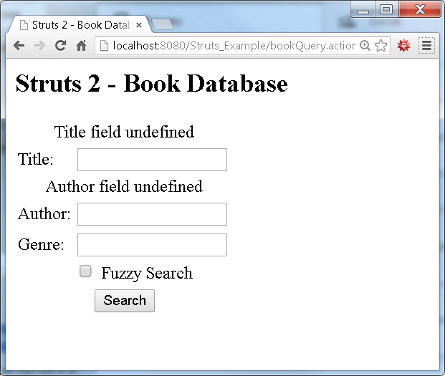

1. Use <s:property value="blurb"/> tags inside of an <s:iterator > </s:iterator> code block to render a table of the query results. Note that the value property on both tags specifies the name of the object in the Action POJO. Note: this has already been done for you. However, make sure you understand how the code works and note how the Book Data Transfer Object (DTO) class is used by Struts to shuttle data between the Database and the User Interface.
2. Use <s:select /> and the following guide to setup a drop down combo to allow a user to select the book genre.

<http://www.mkyong.com/struts2/struts-2-scombobox-combo-box-example/>

<s:select list="criteria" label="Search Options" name ="selectedCriteria" headerKey="1/>

The select list is almost the same as a combo box but does not have the extra s:textfield associated with it.

1. Alter the Action POJOs constructor so that the criteria for the genre drop down are derived from the database using a select distinct query.

